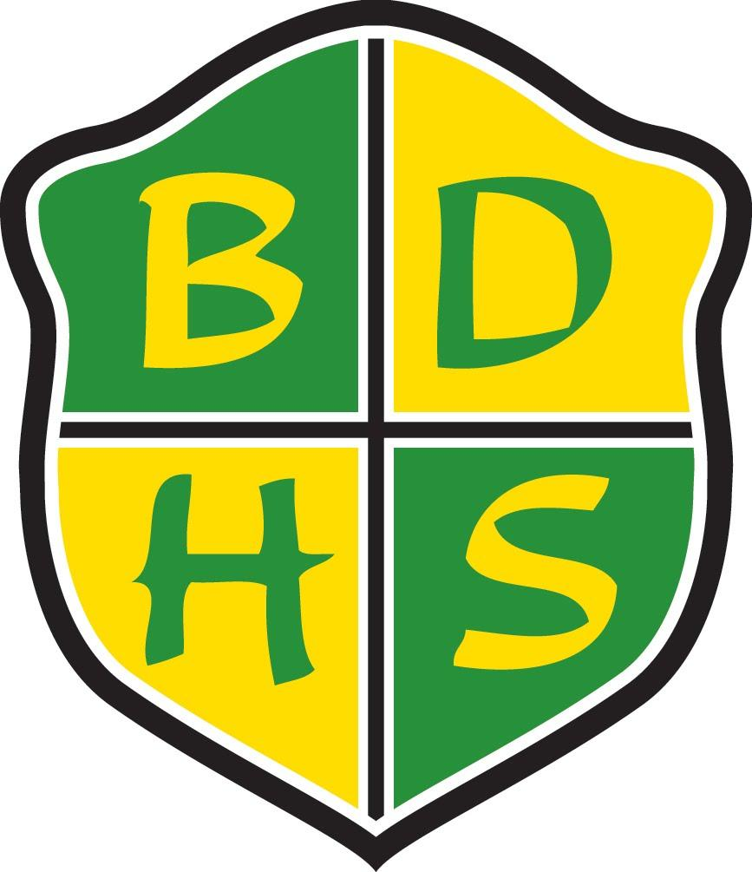
Beaver Dam High School Syllabus
Department: English  School Year: 2016-2017  Course: English 9  Grade Level: 9th  Required Materials: binder, journal notebook, folder, pen/pencil, book cover, post-it notes, highlighter |  |  | Course Resources: Collections Grade 9  (Optional: electronic book available)  Prerequisites: None
Course Description:

In English 9, students develop the literacy and communication skills necessary for future success. Structured around several compelling themes, this course will have students closely reading a variety of challenging literary and informational texts and expressing their growing understanding of course concepts and skills through oral and written forms -- individually and in collaborative groups. The language and vocabulary lessons embedded in each unit build upon students' fundamental understanding of standard English grammar and usage, enabling them to express ideas with greater complexity and precision. Each thematic unit concludes with a performance task, such as writing an analytical paper, and a summative reading/language assessment. These rigorous assessments require students to process essential questions as they transfer the skills and understandings identified in key anchor standards. All assessments place an emphasis on students finding, selecting, and integrating relevant textual evidence in their work.

Units Covered:
First Semester:
Collection 1-Finding Common Ground (Anchor Texts: “A Quilt of a Country” and “Once Upon a Time”)
Collection 2-The Struggle for Freedom (Anchor Texts: “I Have a Dream” and From “Nobody Turn Me Around: A People’s History of the 1963 March on Washington”)
Collection 3-The Bonds Between Us (“And of Clay Are We Created,” “With Friends Like These,” (Poems)= “At Dusk,” “My Ceremony for Taking,” “The Stayer” )
Semester 2
Collection 4-Sweet Sorrow (Anchor Text: The Tragedy of Romeo and Juliet)
Collection 5-A Matter of Life or Death (Anchor Texts: From Night and “The End and the Beginning”)
Collection 6-Heroes and Quests (Anchor Text: From The Odyssey)
Summative Assessments:  - Quizzes  - Tests  - Collection Performance Tasks |  |  | Routine Assessments:  - Communication Activities  - Writing Assignments  - Reading, Vocabulary, and Language Questions
Courses at BDHS run in a flexible schedule format. See selection to right for this course’s format: | One-Term 90 | Two-Term 45 X |  | All-Year 45 | Other
School-wide Grading Procedures:

Assessments 85%
- Routine 30% (of assessment grade)
- Summative 70% (of assessment grade)
Cumulative Final 15%

Summative Assessments: (this shall constitute 70% of the term grade)
Our goal is to assess what the students have learned from what we have taught. Summative assessments reflect the format and content of the formative learning opportunities.

Make-up Policy for Summative Assessment: The student may redo the summative assessment one time within one week after completing all formative tasks and necessary additional learning. It is the student’s responsibility to advocate for this opportunity and make the necessary arrangements.

Cumulative Final: At the end of the semester, there will be a cumulative final exam. Students will not be allowed to retake this assessment. This will comprise 15% of the semester grade.
School-wide Grading Scale:  A+ 98-100 C+ 77-79  A 93-97 C 73-76  A- 90-92 C- 70-72  B+ 87-89 D+ 67-69  B 83-86 D 63-66  B- 80-82 D- 60-62  Expectations  How to be Responsible Be prepared to work as soon as the bell rings. Be an involved, active listener and learner for the entire class period. Bring your planner, binder, pen/pencil, and textbook every day. Use the restroom between classes.  How to be Respectful Talk at appropriate times and communicate respectfully. Turn off and put away all electronics before the bell rings. Sign in/out with time,date, and destination. Minimize classroom disruptions caused by your departure and return.  How to be Safe Keep items and personal belongings to yourself. Stay in your seat until the bell rings. Know how to evacuate the room in case of an emergency.  How to be on time Be in your seat before the bell rings and ready to work. :) |  |  | Contact Information:  Teacher Name: Mrs. Wilke  Teacher Email: WilkeA@bdusd.org  TeacherPhone:920-885-7313 ext. 2123  Beaver Dam High School  500 Gould St.  Beaver Dam, WI 53916  www.beaverdam.k12.wi.us  (920)885-7520  Schedule: First Semester  1st Hour: English 9  2nd Hour: Oral Communication  3rd Hour: Study Hall  4th Hour: Oral Communication  5th Hour: Oral Communication  6th Hour: Plan (not in room)  7th Hour: Oral Communication  8th Hour: Plan (in room)  Schedule: Second Semester  1st Hour: Oral Communication  3rd Hour: English 9B  5th Hour: Oral Communication  6th Hour: Oral Communication  8th Hour: Oral Communication

