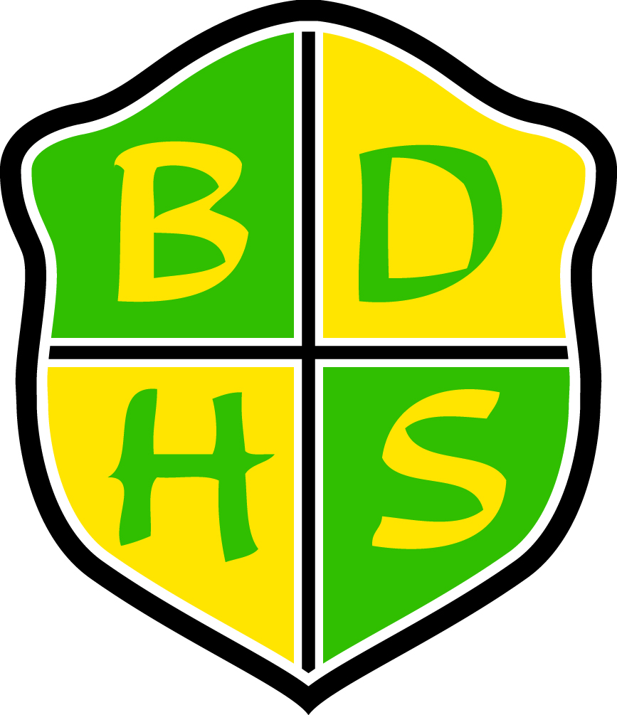
Beaver Dam High School Syllabus
Department: English  School Year: 2015–2016  Course: English 9  Grade Level: 9th  Required Materials: binder, notebook/paper, folder, pen/pencil, book cover |  |  | Course Resources: Collections Grade 9  (Optional: electronic book available)  Prerequisites: None
Course Description:
In English 9, students develop the literacy and communication skills necessary for future success. Structured around several compelling themes, this course will have students closely reading a variety of challenging literary and informational texts and expressing their growing understanding of course concepts and skills through oral and written forms—individually and in collaborative groups. The language and vocabulary lessons embedded in each unit build upon students’ fundamental understanding of standard English grammar and usage, enabling them to express ideas with greater complexity and precision. Each thematic unit concludes with a performance task (such as writing an analytical paper) and a summative reading/language assessment. These rigorous assessments require students to process essential questions as they transfer the skills and understandings identified in key anchor standards. All assessments place an emphasis on students finding, selecting, and integrating relevant textual evidence in their work.
Units Covered:
Semester 1
- Collection 1 – Finding Common Ground (Anchor Texts: “A Quilt of a Country” and “Once Upon a Time”)
- Collection 2 – The Struggle for Freedom (Anchor Texts: “I Have a Dream” and from “Nobody Turn Me Around: A People’s History of the 1963 March on Washington”)
- Collection 3 – The Bonds Between Us (Anchor Texts: “And of Clay Are We Created” and “With Friends Like These” [Poetry = “At Dusk”, “My Ceremony for Taking”, and “The Stayer”])
Semester 2
- Collection 4 – Sweet Sorrow (Anchor Text: The Tragedy of Romeo and Juliet)
- Collection 5 – A Matter of Life or Death (Anchor Texts: from Night and “The End and the Beginning”)
- Collection 6 – Heroes and Quests (Anchor Text: from The Odyssey)
Summative Assessments:  - Quizzes  - Tests  - Collection Performance Tasks |  |  | Formative Assessments:  - Communication Activities  - Writing Assignments  - Reading, Vocabulary, and Language
Courses at BDHS run in a flexible schedule format. See selection to right for this course’s format: | One-Term 90 | Two-Term 45  X |  | All-Year 45 | Other
School-wide Grading Procedures:
Assessments: 85%
- Formative: 30% (of assessment grade)
- Summative: 70% (of assessment grade)
Cumulative Final: 15%
Summative Assessments: (this shall constitute 70% of the term grade)
Our goal is to assess what the students have learned from what we have taught. Summative assessments reflect the format and content of the formative learning opportunities.

Make-up Policy for Summative Assessment: The student may redo the summative assessment one time within one week after completing all formative tasks and necessary additional learning. It is the student’s responsibility to advocate for this opportunity and make the necessary arrangements.

Cumulative Final: At the end of the semester, there will be a cumulative final exam. Students will not be allowed to retake this assessment. This will comprise 15% of the semester grade.

School-wide Grading Scale: |  |  | Contact Information:  Teacher Name: Mr. Brock Linde  Teacher Email: lindeb@bdusd.org  Teacher Phone: (920) 885-7313 x2253  Teacher Website: www.beaverdam.k12.wi.us/faculty/lindeb  Schedule:  - 1: Prep (124)  - 2: Language Arts Intensive (124)  - 3: Prep (124)  - 4: Language Arts Intensive (124)  - 5: Creative Writing (124)  - 6: Creative Writing (124)  - 7: English 9A (124)  - 8: English 9A (124)  Please schedule with me in advance if you would like to meet before school, during one of my preps, or after school.  Beaver Dam High School  500 Gould St.  Beaver Dam, WI 53916  www.beaverdam.k12.wi.us  (920) 885-7313
  A+ | 98-100 | C+ | 77-79
  A | 93-97 | C | 73-76
  A- | 90-92 | C- | 70-72
  B+ | 87-89 | D+ | 67-69
  B | 83-86 | D | 63-66
  B- | 80-82 | D- | 60-62
  Expectations
  How to be  Responsible | - Be prepared to work as soon as the bell rings.  - Be an involved, active listener and learner for the entire class period.  - Bring your planner, binder, pen/pencil, and textbook every day.  - Use the restroom between classes.
  How to be  Respectful | - Talk at appropriate times and communicate respectfully.  - Turn off and put away all electronics before the bell rings.  - Sign in/out with time, date, and destination.  - Minimize classroom disruptions caused by your departure and return.
  How to be  Safe | - Keep items and personal belongings to yourself.  - Stay in your seat until the bell rings.  - Know how to evacuate the room in case of an emergency.
  How to be  on Time | - Be in your seat before the bell rings and ready to work.

