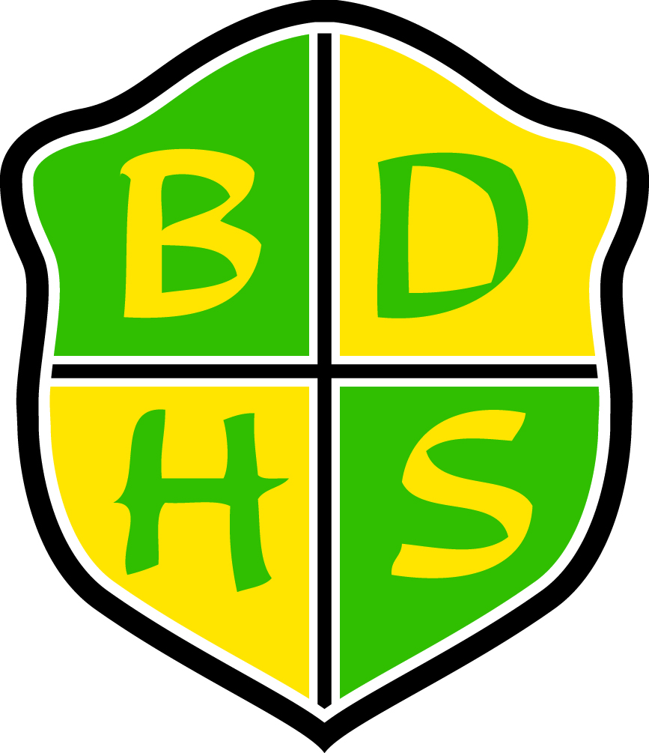
Beaver Dam High School Syllabus

Department: English  School Year: 2015–2016  Course: Creative Writing  Grade Level: 11–12  Required Materials: pens & pencils, loose-leaf paper, three-ring binder with divider tabs (Writing, Grammar, Vocabulary, Notes) | Course Resources: Various in-class handouts (notes, short stories, poems, etc.)  Prerequisites: Recommended for college-bound students. Students taking this course should have at least a C average in English.
Course Description:

This course is designed to develop writing skills in students who are interested in writing fiction, poetry, drama, and personal essays. Students will be encouraged to use personal experience and close observation as sources for imaginative writing. Through writing workshops, students will practice critical and analytical skills, thereby increasing their abilities to evaluate their own writing.

Units Covered:
- Introductions, expectations, writing process
- Descriptive Writing/Setting
- Character (development, characterization, dialogue, archetypes)
- Plot (structure, conflict)
- Poetry
- Language
- Vocabulary exercises
- Grammar exercises

(Students will engage in many writing activities, both informal and formal, on a weekly basis.)

Summative Assessments:  - Tests  - Quizzes  - Writing Pieces (final drafts)  - Performance Tasks | Formative Assessments:  - Outlines  - Journals and Informal Writing  - Writing Pieces (rough drafts)  - Worksheets  - Reading, Vocabulary, and Language Questions
Courses at BDHS run in a flexible schedule format. See selection to right for this course’s format: | One-Term 90 | Two-Term 90 | All-Year 45 | Other:  Two-Term 45  X

School-wide Grading Procedures:

Assessments: 85%
- Formative: 30% (of assessment grade)
- Summative: 70% (of assessment grade)
Cumulative Final: 15%

Summative Assessments: (this shall constitute 70% of the term grade)
Our goal is to assess what the students have learned from what we have taught. Summative assessments reflect the format and content of the formative learning opportunities.

Make-up Policy for Summative Assessment: The student may redo the summative assessment one time within one week after completing all formative tasks and necessary additional learning. It is the student’s responsibility to advocate for this opportunity and make the necessary arrangements.

Cumulative Final: At the end of the semester, there will be a cumulative final exam. Students will not be allowed to retake this assessment. This will comprise 15% of the semester grade.

School-wide Grading Scale:  Be  - Respectful  - Responsible  - Safe  - On Time  - Engaged | Contact Information:  Teacher Name: Mr. Brock Linde  Teacher E-mail: lindeb@bdusd.org  Teacher Phone: (920) 885-7313 ext. 2253  Teacher Website:  www.beaverdam.k12.wi.us/faculty/lindeb  Meeting Times (please schedule in advance):  - Before School (I’m here around 7)  - 1 (Prep: 124)  - 3 (Prep: 124)  - After School (Pending commitments)  Beaver Dam High School  500 Gould St.  Beaver Dam, WI 53916  www.beaverdam.k12.wi.us  (920) 885-7313
  A+ | 98-100 | C+ | 77-79
  A | 93-97 | C | 73-76
  A- | 90-92 | C- | 70-72
  B+ | 87-89 | D+ | 67-69
  B | 83-86 | D | 63-66
  B- | 80-82 | D- | 60-62

